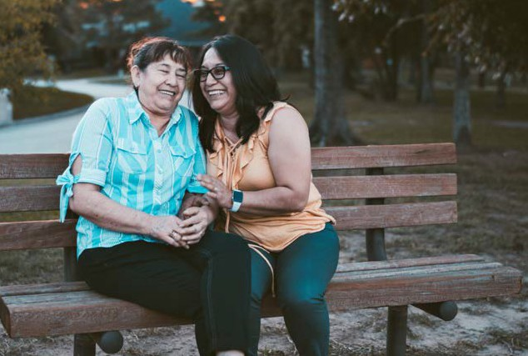
The Way In Network
https://youtu.be/GCA1D0nQdcA

The Way In is a collaboration of Calgary-based agencies dedicated to enhancing quality of life and access to services and support for vulnerable older adults living in the community and their families. Our team connects with older adults in their own homes, or in convenient community locations.

What We Do

The Way In team will help you or your loved ones connect with services and supports in your community including:

- Information and referrals
- Assistance with forms for pensions, benefits, transportation and housing
- Caregiver support
- Access to volunteer supports
- Elder abuse intervention and support
- Commissioner for Oaths
- Assessment and case management
- Group activities and workshops

Our Outreach Workers

Outreach Workers from The Way In teams provide information and connect people (with their consent) to services and resources that they need to age with dignity and in the right place. Our Outreach Workers can meet with older adults in their own home or at a convenient community location.
If you’d like to be connected with one of our Outreach Workers, please call 403-SENIORS (403-736-4677)

These services are offered at no cost to older Calgarians, thanks to the support from The City of Calgary’s Family and Community Support Services (FCSS)

Network Partners
The Way In is a collaboration of Calgary-based agencies dedicated to enhancing quality of life and access to services and support for vulnerable older adults living in the community and their families. Our network is comprised of the following organizations working together:

Our Funders
The Way In is thankful for the major support we receive from the following:
Family and Community Support Services (FCSS), United Way of Calgary and Area, and the Government of Alberta

